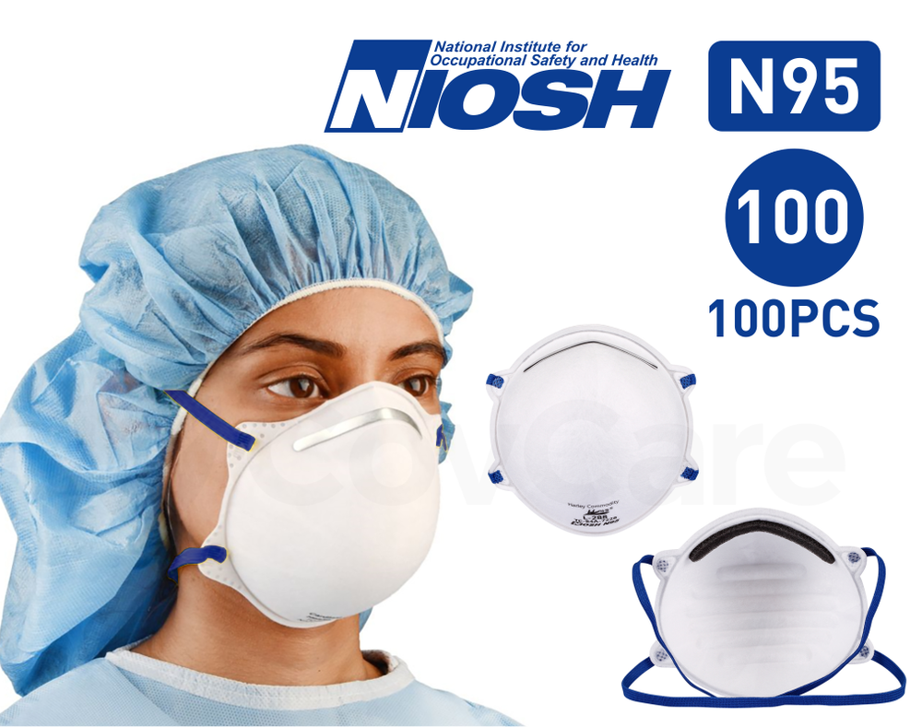

Student Manual

Section Name Description
1 Instructor’s Guide Course delivery information
2 Presentation Slides Power point slides
4 Fit testing Instruction for Fit Testing
4 Competency evaluation Quiz with answer key

Course Duration ~ 1 Hours
Learning Objectives:
At the conclusion of this course students will be able to:

Be familiar with basic disease prevention controls.
Understand the contents of the facility Respiratory Protection Program (RPP) and purpose.
Understand the basics of respirator use, safety and maintenance.
Understand when, how and why to use an N-95 air filtering respirator (APR).
Understand that other tight-fitting fitting and loose-fitting respirators may be use or might be more appropriate for specific types of working environments.
Receive hands-on training on how to successfully fit test facility staff.
Be able to review/modify provided RPP and training document templates to suit the facility program needs together with the Environmental, Health & Safety Department.

Course Outline:
The course will include the following topics:
Basics of Disease Prevention
The hierarchy of controls
Responsible parties for the facility RPP
Basic principles of calculating Maximum Use Concentrations (MUCs)
Staff/Medical Program Requirements
Record Keeping Requirements
When and why to wear a respirator
Fit Testing Program Requirements
Program Respirator Storage and Care Requirements
Other types of loose- and tight-fitting respirators
Train the Trainer fit testing demonstration

Required Equipment/Materials:
Presentation Slides
Copy of Site-specific respirator program
Respirators
Fit testing Equipment
Quiz

PREPARING FOR EMPLOYEE
N95 RESPIRATOR
FIT TESTING

All fit testing will be performed using qualitative fit testing procedures. A qualitative fit test is a type of fit test that uses a bitter or sweet solution to test the seal of a respirator. The test is conducted in a hood that covers the employee's head and face, with a clear front so the employee can see forward. The employee wears the respirator and performs a series of exercises. If the employee can taste the solution, then the respirator does not fit properly, and the test is failed.
A saccharin (sweet) or bitrex (bitter) solution is used for the fit test. These solutions have a very strong taste that is easy to detect. The solutions are also non-toxic and safe to use.
Please review the following considerations to prepare for the fit testing service. These considerations should ensure employers can help to ensure that their employees are properly prepared for their upcoming fit testing service.

PREPARING YOUR SPACE
- Identify a space for training and, if available, an adjacent well-ventilated space for conducting the fit test.
  - The training space should be large enough to accommodate all of the employees who will be fit tested, with a work desk or Table for the Safety Department to process employees and set-up equipment.
  - The fit testing space should be well-ventilated to prevent the buildup of fit testing solution in the air.
- Provide water for employees at the fit testing area.
- Organize staff into groups of about 10-15 people at a time. This will help to ensure that the fit testing process is efficient and that employees do not have to wait too long to be tested.
- Ensure adequate supply of respirators are available for selection and fit testing. Each employee should be fit test with a new N95 mask. Adequate supply will accommodate all employees, with a variety of respirators and sizes to choose from.

EMPLOYEE PREPARATION
- Provide the Safety Department with proof of medical clearance for each employee. This is required by OSHA. You may provide us with a list of employees who have been medically cleared to wear a respirator, with any notification of use limitations imposed by the evaluating physician or other licensed health care practitioner (PLHCP).
- Notify supervisors and instruct employees to expect to be at the fit testing for about 1 to 1.5 hours. This includes the time for training and the fit testing itself.
- Instruct employees:
  - Do not eat, drink, smoke, or chew gum for at least 15 minutes prior to the scheduled fit test (water is ok). These things can reduce or eliminate an employee’s ability to taste the fit test solution.
  - To shave before the fit test. Facial hair can interfere with the seal of the respirator, and any employee with facial hair between the face and face-piece sealing surface will not be fit tested.
  - Do not wear any makeup or jewelry on their face for the fit test. These items can also interfere with the seal of the respirator.

SAFETY DEPARTMENT WILL CONDUCT FIT TESTING
- Provide each group of employees with training on the proper use of respiratory protection devices. This training will include information on how to put on and take off the devices, how to adjust the fit, and how to care for the devices.
- Document the results of the fit testing and provide a record of the fit test to the employee. This documentation will help to ensure that employees are using the correct respiratory protection devices and that the devices are providing adequate protection.

Fit Test Supplies
- Fit Test Nebulizers & Solutions
- Fit Test Hoods
- Rainbow Passage
- Fit Test Record
- Fit Testing Certificates
- Fail Form
- Respirators – Minimum 2 sizes (Reg & Small) of each approved brand
- Hydrogen Peroxide Wipes

PPE Supplies for Fit-Tester
- N95 or surgical mask
- Gloves
- Hand Sanitizer

Set-Up for Fit Testing
- Lay out Fit Test Record forms with pens.
- At end of table, have folder with Training/Fit Testing Certificates and Respirator Stickers. We suggest that you pre-sign the certificates.
- Fill nebulizers with fit testing solutions (do not overfill):
  - One with sensitivity solution (check label on nebulizer).
  - One with fit testing solution (check label on nebulizer).
  - Make sure each nebulizer works properly. If not, try rinsing out with warm water.
- Clean out Fit Test Hoods with hydrogen peroxide wipe.

Procedure
- Introduce yourself
- Have fit test subject complete a facility Fit Test Record and place their ID or other employee number on top of the record.
- Review the Fit Test Record to ensure that test subject has completed the Medical Clearance section. *Note: If records are not completed, then do not fit test the subject.
- Ensure that any subject being fit tested is clean shaven and/or does not have facial hair (including beard stubble), jewelry or other physical obstructions that would interfere with the seal of the respirator. Where this may be the case, politely explain that they cannot be fit tested at this time and to contact their facility safety representative.
- Conduct demonstration on proper procedure for donning and doffing each type of respirator present. Often there will be different models and manufacturers.
- Perform sensitivity test for each person being tested without the test hood (note how many sprays are needed 10, 20, or 30). Note: usually you don’t need more than a few however, so if it is 10, then list 10.
- On the Fit Test Record (Fit Tester Section) fill in blanks on both sides of two-sided sheet:
  - Clearly print the name of the fit test subject/unique identifiers at the top.
  - Fill in the test’s name.
  - Check the appropriate Fit Testing test method.
  - List the appropriate box for # of sprays for sensitivity check.
  - List requested respirator information for specific staff being fit tested.
  - Assess facial interferences (i.e., glasses, facial hair, jewelry, etc.).
- Have fit test subject don fit-testing hood.
- Conduct Fit Testing Exercises:
  - 60 seconds each step.
  - Follow listed steps on the Fit Test Record form.
  - For each test subject, remember to spray every 30 seconds (with the fit testing solution) the same number sprays as was necessary for the subject during the sensitivity test. The minimum is 10.
  - Remember to remind test subject to breathe through their mouth and notify you if they detect the test.
  - After the last step, and before removing the hood, ask the test subject to put their hand inside the hood and then, with one finger, break the seal of the respirator on their face. Ask them to take a breath through their mouth. They will probably grimace in surprise at the sudden taste of the strong solution inside the hood.
- Recordkeeping
  - Fit Test Certificate to be provided to the test subject if they pass.
  - If test subject failed, try retesting the subject with another size mask.
  - Fit Test Record – complete the check boxes of the Fit Test Exercises of the Fit Tester Section.
  - Check appropriate box for the Pass or Fail certification.
  - Check the other box and print your name.
  - Put initials below your name.
  - Return completed forms to facility site representative.

Respiratory Protection Training (“Train the Trainer”) pre Quiz

Name: ____________________________________ Date:
*To be given at the beginning of training. Note: a minimum score of 8/10 (80%) is required to pass this “Train the Trainer” Module

1. A Respiratory Protection Plan (RPP) should be implemented together with:
A. Recommended/required disease prevention program with other good hygiene measures,
B. Proven/required facility maintenance practice(s)
C. Hierarchy of Controls (i.e., elimination/substitution, administrative, Engineering then PPE)
D. Dynamic/continual Team re-evaluation of facility needs
E. All the above (i.e., integrated approach)

2. What are the requirements required to wear a respirator?
A. Medically Qualified
B. Annual training
C. Successful fit testing (at least annually)
D. All the above

3. Who are respirator cartridges and N-95 Respirators approved by?
A. NIOSH
B. OSHA
C. ACGIH

4. A limitation of using an Air Purifying Respirator is?
A. Oxygen concentration in the surrounding ambient air
B. Cartridge type/color
C. Respirator size
D. All of the above are limitations

5. An N-95 Respirator (APR), when used correctly, can remove up to 95% of what?
A. Particulates
B. Fumes/mists
C. Biological particles (i.e., pollen, mold spores, bacteria, viruses and allergens)
D. All the above

6. An air purifying respirator (APR) can safely address?
A. Low oxygen in the surrounding environment
B. Underwater work activities
C. High hazard environments
D. None of the above

7. Use of an N-95 and other respirators may be considered after implementing what other controls?
A. Engineering
B. Elimination/substitution
C. Administrative/Training
D. All the above (i.e., Hierarchy of Controls)

8. Which is not true about an Air Purifying Respirator?
A. Allows for independent movement
B. Can be used for most low-level contaminants
C. Can address limited air supply in the surrounding environment

9. A HEPA Filter can remove 99.97% of which of the following down to 0.3 microns?
A. Particulates
B. Vapors
C. Gases
D. All the above

10. What are the two (2) seal checks that are to be performed when a respirator is donned?
A. Up and down
B. Side to side
C. Positive and negative
D. High and low

Respiratory Protection Training (“Train the Trainer”) Quiz

Answer Key

- D
- D
- A
- C
- D
- D
- A
- C
- D
- E

Respiratory Protection Training (“Train the Trainer”) Post-Quiz

Name: ____________________________________ Date:
*To be given at the completion of training. Note: a minimum score of 8/10 (80%) is required to pass this “Train the Trainer” Module

1. What are the requirements required to wear a respirator?
A. Medically Qualified
B. Annual training
C. Successful fit testing (at least annually)
D. All the above

2. An N-95 Respirator (APR), when used correctly, can remove up to 95% of what?
A. Particulates
B. Fumes/mists
C. Biological particles (i.e., pollen, mold spores, bacteria, viruses and allergens)
D. All the above

3. Who are respirator cartridges and N-95 Respirators approved by?
A. NIOSH
B. OSHA
C. ACGIH

4. Which is not true about an Air Purifying Respirator?
A. Allows for independent movement
B. Can be used for most low-level contaminants
C. Can address limited air supply in the surrounding environment

5. A limitation of using an Air Purifying Respirator is?
A. Oxygen concentration in the surrounding ambient air
B. Cartridge type/color
C. Respirator size
D. All of the above are limitations

6. An air purifying respirator (APR) can safely address?
A. Low oxygen in the surrounding environment
B. Underwater work activities
C. High hazard environments
D. None of the above

7. A HEPA Filter can remove 99.97% of which of the following down to 0.3 microns?
A. Particulates
B. Vapors
C. Gases
D. All the above

8. What are the two (2) seal checks that are to be performed when a respirator is donned?
A. Up and down
B. Side to side
C. Positive and negative
D. High and low

9. Use of an N-95 and other respirators may be considered after implementing what other controls?
A. Engineering
B. Elimination/substitution
C. Administrative/Training
D. All the above (i.e., Hierarchy of Controls)

10. A Respiratory Protection Plan (RPP) should be implemented together with:
A. Recommended/required disease prevention program with other good hygiene measures,
B. Proven/required facility maintenance practice(s)
C. Hierarchy of Controls (i.e., elimination/substitution, administrative, Engineering then PPE)
D. Dynamic/continual Team re-evaluation of facility needs
E. All the above (i.e., integrated approach)

Respiratory Protection Training (“Train the Trainer”) Post-Quiz

Answer Key

- D
- D
- A
- C
- D
- D
- A
- C
- D
- E

- The objectives of the training were clearly defined
- Strongly agree
- Agree
- Neutral
- Disagree
- Strongly disagree

- The content was organized and easy to follow
- Strongly agree
- Agree
- Neutral
- Disagree
- Strongly disagree

- The materials distributed were pertinent and useful
- Strongly agree
- Agree
- Neutral
- Disagree
- Strongly disagree

- Was the mix of presentations and hands-on activities suitable?
- Strongly agree
- Agree
- Neutral
- Disagree
- Strongly disagree

- The quality of the instruction was good
- Strongly agree
- Agree
- Neutral
- Disagree
- Strongly disagree

- The trainer met the training objectives
- Strongly agree
- Agree
- Neutral
- Disagree
- Strongly disagree

- Class participation and interaction were encouraged
- Strongly agree
- Agree
- Neutral
- Disagree
- Strongly disagree

- I will be able to apply the knowledge learned
- Strongly agree
- Agree
- Neutral
- Disagree
- Strongly disagree

- I have a good understanding of the Respiratory Protection Programs and how they apply to my organization
- Strongly agree
- Agree
- Neutral
- Disagree
- Strongly disagree

- I am confident I will be able to fit test staff at my organization
- Strongly agree
- Agree
- Neutral
- Disagree
- Strongly disagree

- How do you rate the training overall?
- Excellent
- Good
- Average
- Poor
- Very Poor

- What aspects of the training could be improved?

- Other comments?

